

**UNIVERSITY OF PETROLEUM & ENERGY STUDIES**

**SCHOOL OF COMPUTER SCIENCE**

***Department of Cybernetics***

**GRAPHICS AND ANIMATIONS TOOLS**

LAB FILE

SESSION (2020-21)

Course: BTech with specialization in Open Source & Open Standards

Submitted to: Submitted by:

Dr. Durgansh Sharma Surabhi Kumari

Associate Professor SAP: 500063663

Department of Cybernetics Roll no: R100217101

**Experiment-9**

Design of MOUNTAIN using Blender

STEP 1: Open Blender.

STEP 2: Create a new file -> Delete the default cube.

STEP 3: First add a plane

STEP 4: Subdivide the plane once and repeat the step twice.

STEP 5: Add displacement modifier to the plane.

STEP 6: Add clouds texture to the displacement modifier.

STEP 7: Add a uv sphere as a controller to adjust and move the mountains terrain.

STEP 8: Set uv sphere as the controller in displacement modifier.

STEP 9: Create a vertex group and select all vertices of the plane and assign to the vertex group.

STEP 10: Add vertex weight proximity modifier and set the vertex group created above and target object as the uv sphere.

STEP 11: In the plane settings invert the lowest and highest parameter values.

STEP 12: In vertex weight proximity modifier set distance parameter as geometry.

STEP 13: Add subdivision surface modifier and set is the first modifier for the plane.

STEP 14: At last using the sphere create your mountain structure as required.

STEP 15: Color the mountain using the required colors.

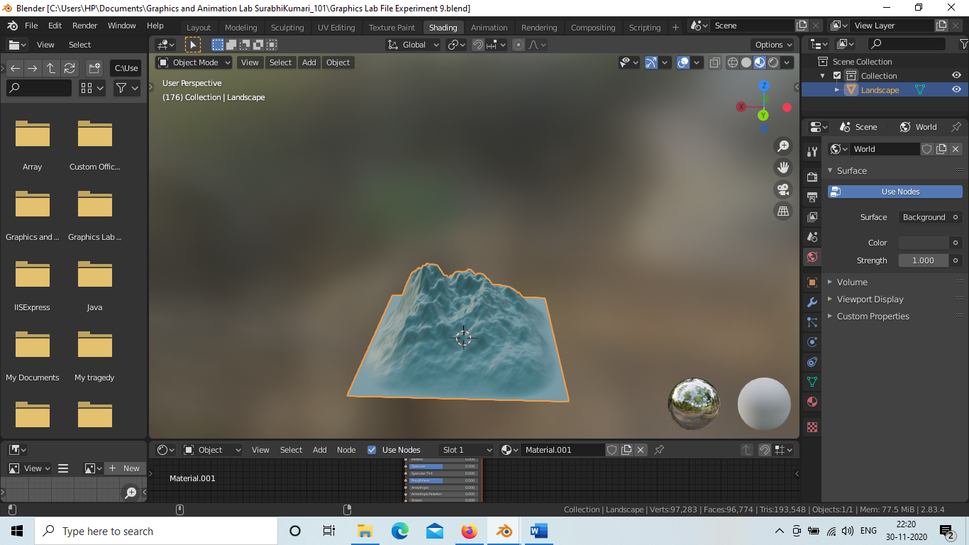

[Link for the Project](https://drive.google.com/drive/folders/1QW51b1vKovsRW5VJctBd0HDfJOzjuHIa?usp=sharing)